CMPSC 431W

Yuanpei Deng

Supplier:

In our case, supplier is the car dealer. The attributes of supplier (dealer) are dealer name, address, phone number and rates. The rate is how buyers (user) judge the dealer by several aspects, like customer service, quality of repair, buying process, etc. Dealer will have an inventory. The relation is called owns and the entity is cars. The dealer also has a relation named locates and the entity is address. The reason I choose make “address” as an entity instead of an attribute is that we can use the similar schema for registered users. The ER diagram looks like this:

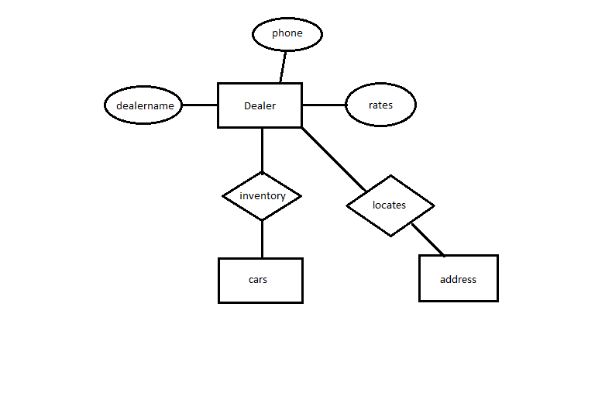

Registered Users:

The registered users are the buyers who can buy or bid on an item (car). Buyer must be registered, and identified by a user name and authenticated with a password. When registering, the user must enter the following required information in order to register successfully. These information includes: email address, name, address, phone number and credit card info like type of card, card number, cvv and expiration date. These are the basic information of a registered user. This picture shows how does the interface of registering page look like. (In real design the credit card information will be added.)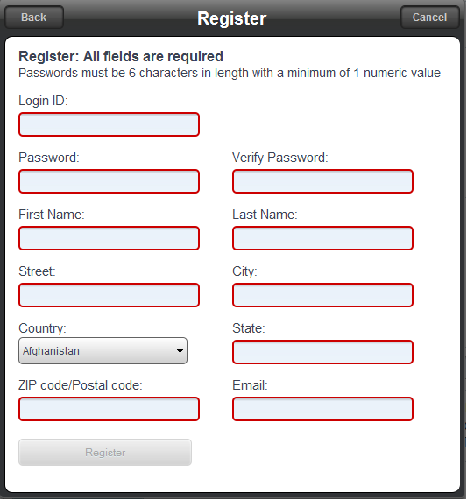

In addition, after register a user can complete his whole profile by adding other information like age, gender and annual income. These attributes can be NULL if the user chooses not to fill. The ER diagram will roughly looks like this:

